

Python Practical’s

# TASK 4

Smit Joshi | 07-08-2023

View On [**github.com/smit-joshi814**](https://github.com/smit-joshi814/Learning-python/tree/main/collage/Task4)

# Practical 1

Write a python function for calculating cube of the number. Define a second function called by_three that takes an argument called Number. If that number is divisible by 3, by_three should call cube(number) And return its result. Otherwise, by_three should return false.

# functions start

def cube(number):

    return number*number*number

def by_three (number):

    if number%3==0:

        return cube (number)

    else:

        return False

# functions end

### Output:

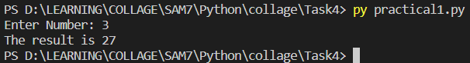

# Practical 2

Write a python function to print all the prime numbers between the specific range given by user.

# getPrimes Start

def getPrimes (start, end):

    for number in range (start, end+1):

        isPrime=True

        for i in range (2, number):

            if number %i==0:

                isPrime=False

        if isPrime:

            print(number, end=" ")

# getPrimes End

print("Enter range To get Prime Numbers! ")

start=int(input("start: "))

end=int(input("end: "))

getPrimes (start=start, end=end)

### Output:

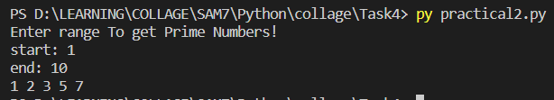

# Practical 3

Write a menu driven program for creating calculator with arithmetic Operations. Create functions for +,-,* and / and call those functions in switch Case.

# functions start

def sum(num1,num2):

    return num1+num2

def minus(num1,num2):

    return num1-num2

def multiply(num1,num2):

    return num1*num2

def devide(num1,num2):

    return num1/num2

# functions end

num1=int(input("Enter Num 1: "))

num2=int(input("Enter num 2: "))

ans=0

operator=input("Which Operation you want to perform? [+] [-][*][/] : ")

match operator:

    case '+':

        ans=sum(num1, num2)

    case '-':

        ans=minus(num1, num2)

    case '*':

        ans=multiply(num1,num2)

    case '/':

        ans=devide(num1, num2)

    case default: print("Invalid choice")

print(f"The Answer is: {ans}")

### Output:

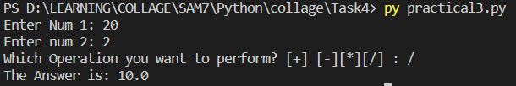

# Practical 4

Write a function to print following patterns:

1. 1 0 1 0 1 (II) 1 (III) *

0 1 0 1 0 2 3 * *

1 0 1 0 1 4 5 6 * * *

0 1 0 1 0 7 8 9 10 * * * *

1 0 1 0 1 * * * * *

* * * * *

* * * *

* * *

* *

*

def printPattern_1(limit):

    for i in range (1, limit+1):

        if i%2==0:

            for j in range(1, limit+1):

                if j%2==0: print("1 ", end="")

                else:      print("0 ",end="")

        else:

            for j in range(1, limit+1):

                if j%2!=0: print("1 ", end="")

                else:      print("0 ", end="")

        print()

def printPattern_2(limit):

    counter=0

    for i in range(1,limit):

        for j in range(i):

            counter+=1

            print(counter,end=" ")

        print()

def printPattern_3(limit):

    for i in range(limit):

        for j in range(i):

            print("*",end=" ")

        print()

    for i in range(limit,0,-1):

        for j in range(i):

            print("*",end=" ")

        print()

limit=int(input("Enter Limit: "))

print("<------Patteren i ------>")

printPattern_1(limit=limit)

print()

print("<------Patteren ii ------>")

printPattern_2(limit=limit)

print()

print("<------Patteren iii ------>")

printPattern_3(limit=limit)

### Output:

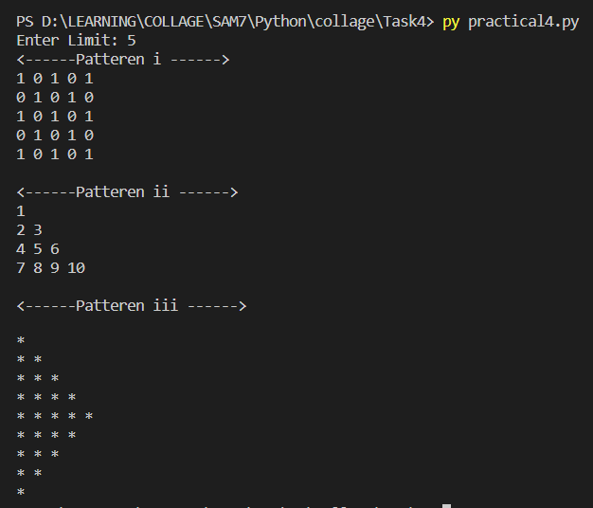

# Practical 5

Write a python function to find the factorial of the number.

# Function start

def factorial(number):

    if number>1:

        # recursive approach

        return number*factorial(number=number-1)

    else:

        return 1

# function end

number=int(input("Enter Number: "))

print(f"The Factorial of {number} is: {factorial(number=number)}")

### Output:

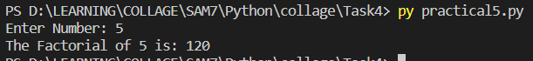

# Practical 6

Write a python function to find the gcd of two numbers

def findGCD(num1,num2):

    i=1

    gcd=0

    while i<=num1 and i<=num2:

        if num1%i==0 and num2%i==0:

            gcd=i

        i+=1

    return gcd

num1=int(input("Enter Number 1: "))

num2=int(input("Enter number 2: "))

print(f"The Greatest comman Deviser of {num1} and {num2} is : {findGCD(num1=num1,num2=num2)}")

### Output:

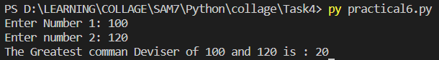

# Practical 7

Write a python function to find the sum and average of all the elements in the List. Return these values and print them outside the function.

def sum_average(numbers):

    sum=0

    for number in numbers:

        sum+=number

    average=sum/len(numbers)

    return sum,average

myList=[100,90,10,56,50,89,67,45,100,780,]

sum,average=sum_average(myList)

print(f"sum is {sum} and average is {average}")

### Output:

